|  |  |
| --- | --- |
| **Digital Forensics**  Diploma in CSF/IT  Year 2/3 (2022/23) Semester 4/6 | Week 7 |
| Tutorial 6 |
| **NTFS Analysis** | |

**OBJECTIVES**

After completing this topic, you should be able to

1. Perform Hexadecimal number addition without using calculator;
2. Perform forensic analysis on NTFS file system;
3. Explain the difference between different timestamps in MFT.

Q1: Perform addition on the hexadecimal numbers using Table 1.

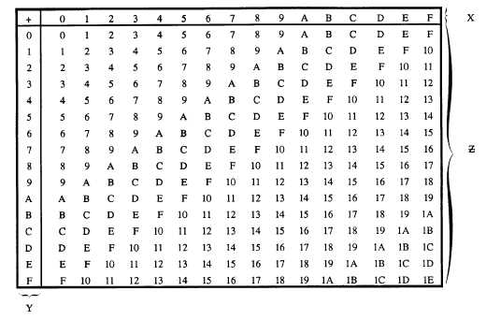

Figure 1: Hexadecimal Addition Table



|  |  |  |  |
| --- | --- | --- | --- |
|  | 4 | 5 | 616 |
| + | 7 | 8 | 416 |
|  | B | D | A |

|  |  |  |  |
| --- | --- | --- | --- |
|  | 7 | 8 | 416 |
| + | B | D | A16 |
| 1 | 3 | 5 | E |

|  |  |  |
| --- | --- | --- |
|  | 9 | 816 |
| + | 7 | 816 |
| 1 | 1 | 0 |

Q2. Figure 2-1 shows the MFT record of an NTFS file system.

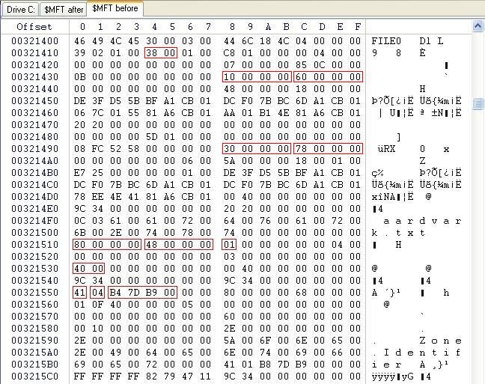

Figure 2-1: MFT File Record

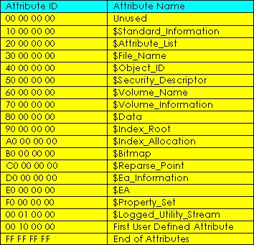

Figure 2-2: NTFS Attributes

Answer the following with reference to Figure 2-1 and 2-2. You may use Hex addition table or calculator to perform the addition.

1. What is the byte offset to the first attribute? 0x38(Hex)
2. What is the attribute name of this first attribute? $Standard_Information

The next 4 bytes immediately after attribute type is the length (in bytes) of that attribute.

1. What is the length of first attribute? 0x60 (Hex)
2. What is the byte offset of second attribute? 0x98 (Hex)
3. What is the attribute name of second attribute? 0x30 (Hex) ($File_Name)
4. What is the name of the file in this entry? Aardvark.txt
5. What is the byte offset of the file content ($Data)? 0X110

Q3. (a) An investigator was examining a hard disk drive that was formatted with NTFS file system. Figure 3(a)-1 shows an entry/record in the Master File Table (MFT) and Figure 3(a)-2 and Figure 3(a)-3 show the list of NTFS attributes and Attribute header respectively.

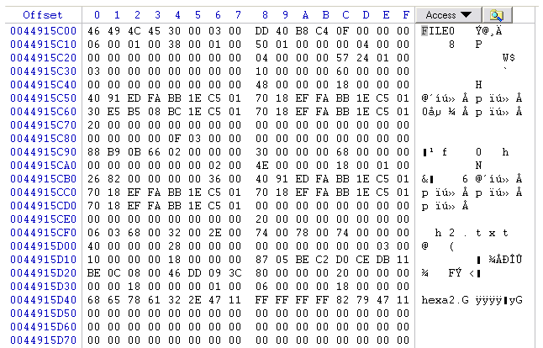

**Byte offset 0x38**

Figure 3(a)-1: An Entry/Record in Master File Table



Figure 3(a)-2: NTFS Attributes

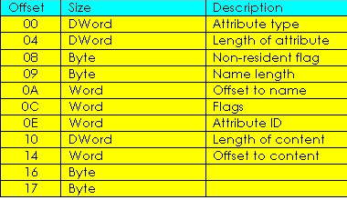

Figure 3(a)-3: Attribute Header

Given that the byte offset to the first attribute is **0x38** (hex), based on Figure 3(a)-1 to 3(a)-3 above, answer the following questions:

* 1. How do you tell if this MFT entry is a valid/usable entry? What represents an unusable entry?

If the first 4 bytes of the MFT shows the file identifier ‘FILE’, it is a valid/usable entry

An unusable entry will be shown as ‘BAAD’

* 1. What is the name of the file/folder represented by this entry?

H2.txt

* 1. Complete the following table for this MFT entry.

|  |  |
| --- | --- |
|  | Attribute Name |
| 1st Attribute | $Standard_Information (0x38) |
| 2nd Attribute | $File_Name (0x98) |
| 3rd Attribute | $Object_ID (0x100) |
| 4th Attribute | $Data (0x128) |

* 1. Is the 4th attribute a Resident or Non-resident attribute? Explain.

The non-resident flag for the 4th attribute is ‘00’, as shown at byte offset 0x130, which means this is a resident attribute

* 1. Which location on the hard disk can you find the content of this file? Explain.

The content of the file can be found in the MFT, as $Data shows that this is a resident file.

(b) Briefly explain how Windows operating system stores files of the following sizes in disk drive configured with NTFS with respect to the Master File Table (MFT). In your answers, explain how the Non-Resident flag is set.

* 1. 100 Bytes
  2. 5 Kbytes

Small Files (<700B) are contained completely in the FT entry. It is a resident attribute, hence non-resident flag is set to 0.

As the file is larger than 700B, the content of the file is stored outside the MFT table. It is a non-resident attribute, hence Non-resident flag is set to 1.

Q4. Where is the Volume Boot Record (VBR) located in the NTFS partition?

The Volume Boot Record

Q5. Both $Standard_Information and $File_Name contain MACE timestamps. Explain the difference between the timestamps found in these 2 attributes.

$FN timestamps refer to the MFT entry fir the file name itself. For instance, Filename Created refers to the date and time on which the MFT entry for a given file was created. Filename modified refers to the date and time on which a file name attribute in the MFT last changed and so on.

$SI timestamps are available to user applications through Windows API. This means that programs can read and change any of these timestamps to a different (intentionally inaccurate) value. Malware can make use if thus to hinder timeline analysis as counter forensic technique.

- End -